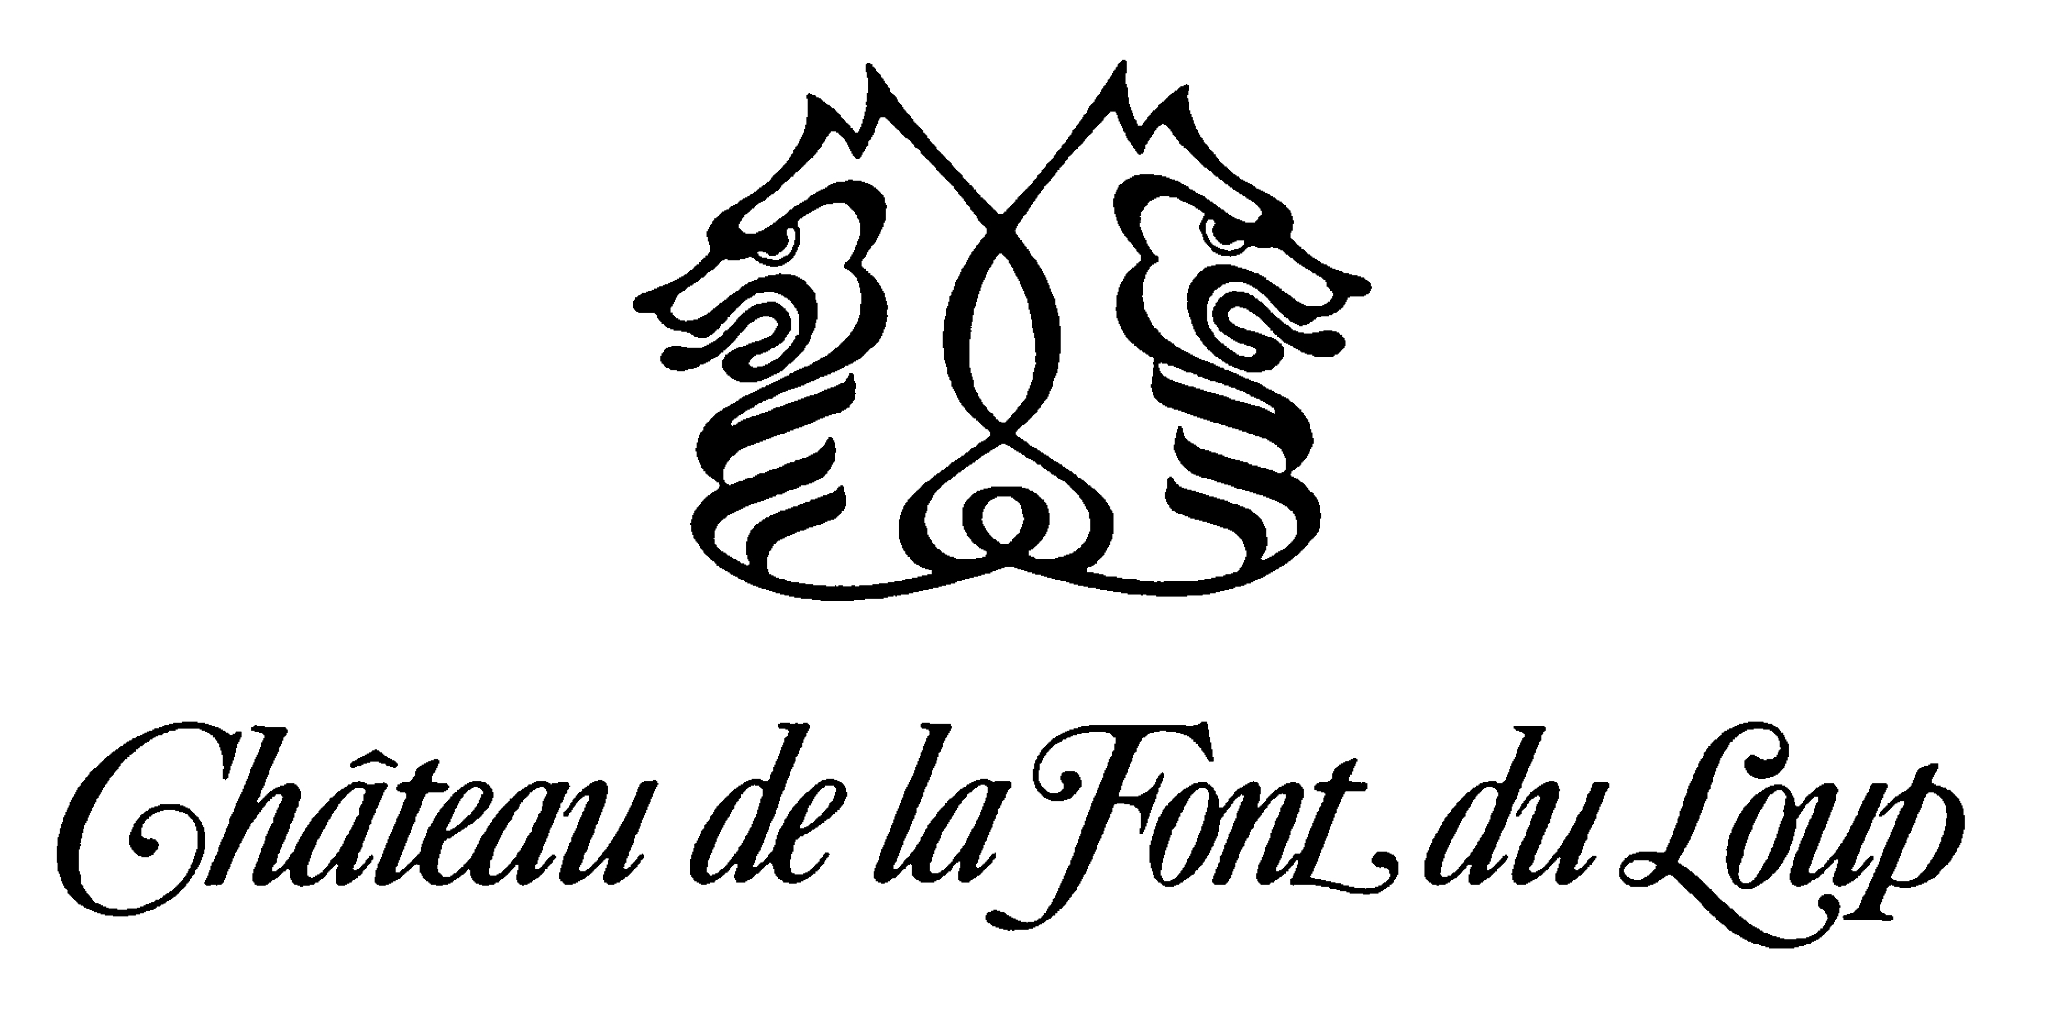
Font du Loup is quite unique in that our vineyards are on north-facing slopes and the soils have a high percentage of sand. These north-facing, sandy plots tend to ripen more slowly. As such, we harvest on average two weeks later than other estates. This results in wines that are more complex, aromatic and contain less alcohol. The style here is towards elegance and finesse rather than power and extraction. Our style adds a refreshing change of pace to a region whose wines have become a touch heavy.

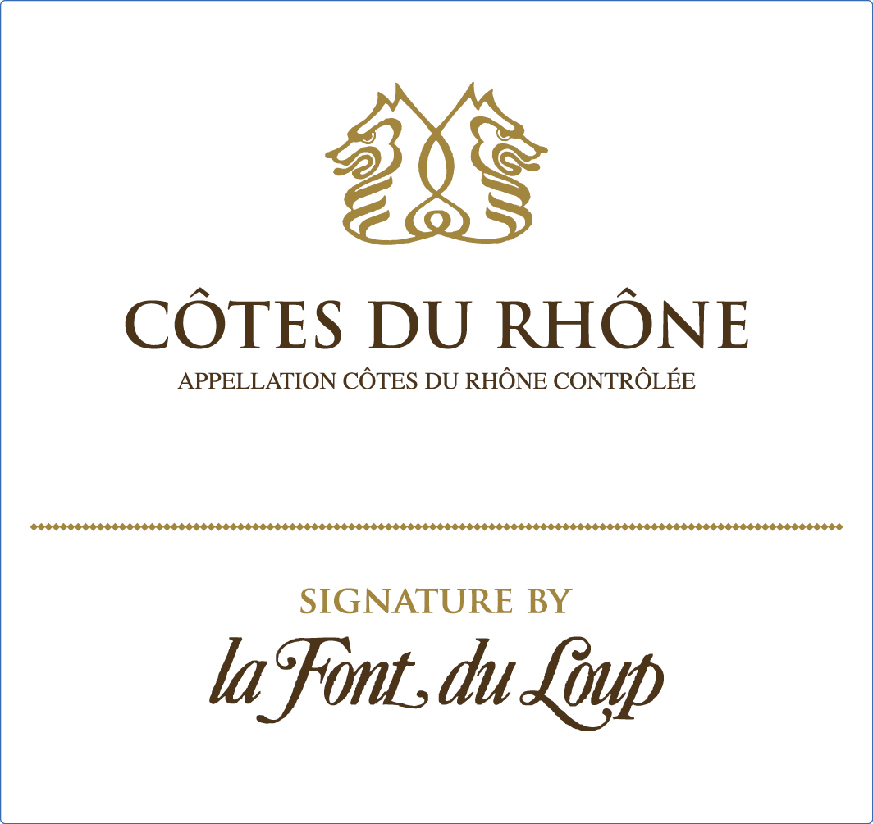 | SIGNATURE BY LA FONT DU LOUP 2020 WHITE  80% Grenache blanc, 10% Clairette and 10% Viognier vinified and aged in stainless steel vats for 6 months.  Complex, delicate, floral and fresh with a nice hint of honey, made to be an easy drinking white Côtes du Rhône.  Pairing : Cheese plate, fish, oysters, crawfish, poultry

